Trevor Brown
ITLS 6245
Final Project 1st draft

Introduction
As an engineering department, we have noticed many 9th grade students struggle with manipulating and rearranging equations. These students come in near the top of their grade and come from multiple junior high schools in the school district. However, they lack the problem solving skills needed to succeed in engineering classes. These students do well when given specific problems where the direct formula is given and they only need to plug in the numbers. However, when they are given a formula with information such that they cannot directly plug in the numbers, they struggle to take the necessary steps to solve for a specific variable.
Because of the gap of understanding, there needs to be a better way to teach students these skills such that during any unit of instruction during the class, they know what needs to get done and can find success regardless of the content. The hope is to find an activity that illustrates basic algebra skills with formulas. As students learn the basic algebraic skills, they will understand the real world application of mathematics and see how mathematics can be used to perpetuate their designs and projects.
These students also struggle to identify the relevant information in a given story problem. They read a story problem and misidentify information and don’t know how to use the language given to know what each piece of information means. There needs to be a guide that helps them through how to know what information is useful and what isn’t useful. In addition to that, there needs to be engaging activities that help them practice this skill.
The project would include creating an activity that teaches the learner how to rearrange and manipulate formulas. There would be a section that teaches how to read and understand a story problem. There would be a section that explains the GUESS method and how to use it with a story problem.

Learning Goals
At the end of the activity, the learner will be able to:
- Identify each letter meaning in PEMDAS (Parentheses, Exponents, Multiply, Divide, Add, Subtract) with 100% accuracy from memory.
- Understand order of operations using PEMDAS by applying PEMDAS to rearrange an equation only using PEMDAS operators at 100% accuracy from memory.
- Complete the levels of the application at 100% completion, given the Solve Equation application.
- Identify each part of the GUESS method (Given, Unknown, Equation, Substitute, Solve) at 100% accuracy from memory.
- Identify, label and use key information from a given story problem with 100% accuracy.

Target Audience
This application is aimed at helping freshman (about 14 or 15 years old) in high school, specifically for students in the Principles of Engineering course. These students rank high in the school district in terms of math and overall GPA. These students are expected to understand how to use a computer and should have a general understanding of using technology.

Limitations
There are some limitations for this project. Below is a list for each one and how it will impact the project:
- Project in Progress: This project is a continuation of work that has already been done. The work that has been done consists of menus for the game (main menu and level selection), 20 levels created for the game, a tips page, and a credits page. This project would create:
  - A set of pages that takes the learner through learning PEMDAS (see Learning Objectives found above) and provide examples of applying PEMDAS
  - A set of pages for learning the GUESS method (see Learning Objectives found above) with examples of different story problems and the GUESS method used to solve those problems
  - A set of pages that explains how to use the software and tricks for being successful while using the software, in other words a tutorial
  - Links from the original game to these newly added pages
  - Documentation of the project
- Work with Colleagues: This project will be done with the help of my colleagues. Because this is a department issue at the school I am at, they want to help organize the content for this game. See the tasks above for a more detailed idea of these tasks. My colleagues have ideas and strategies for teaching this unit. We want to develop something that is meaningful and that teaches them the skills they need to be successful throughout our program as well as when they get into college or on the job.
- Classroom Setup: This project will be implemented in a classroom with a full set of computers. The application can be put on those computers. A web based game would be most ideal so that students could play this game at home. However, server space probably won’t be available to host this game.
- Budget: There is no budget for this game. All of the features of this game will become developed through my free time or during my preparation period.
- Time: See the Timeline section below for more information on time constraints.
Timeline
There are about four weeks to work on the project. The tasks are creating:
- A set of instructional pages for PEMDAS (about 7 hours)
  - Creation of each page (1 hour)
  - Transitions / navigation between pages (1 hour)
  - Creation of instructions, images and assets (1 hour)
  - Additions of instructions, images and assets for each page (2 hours)
  - Transitions in each page for the instructions, images and assets (1 hour)
  - Basic quiz questions given throughout the instruction (1 hour)
- A set of instructional pages for GUESS method (6 ½ hours)
  - Creation of each page (1 hour)
  - Transitions / navigation between pages (1/2 hours)
  - Creation of instructions, images and assets (1 hour)
  - Additions of instructions, images and assets for each page (2 hours)
  - Transitions in each page for the instructions, images and assets (1 hour)
  - Basic quiz questions given throughout the instruction (1 hour)
- A set of instructional pages for using the application (3 ½ hours)
  - Creation of each page (1/2 hour)
  - Transitions / navigation between pages (1/2 hours)
  - Creation of instructions, images and assets (1/2 hour)
  - Additions of instructions, images and assets for each page (1 hours)
  - Transitions in each page for the instructions, images and assets (1 hour)
- Debugging and troubleshooting (5 hours)
- Creating documentation for the project (2 hours)
  - Create documentation (1 hour)
  - Revising document (1 hour)
Each of these tasks are listed above in detail in the Project in Progress subsection within the Limitations section. Many of the instructional aids will be made as I discuss with my colleagues. Those aids are not included in the actual project, but these will probably take 2 to 3 hours of discussion.
Risk Assessment
Some of these tasks could take longer than expected. Here is a list of many aspects that introduce risk into the project.
- (higher risk) Each page in the tutorial would need to have different visuals, such as descriptions of what to do and images of what is happening. This could be the longest part of the project. Creating good visuals may take a good amount of time due to the many visuals that need to get created for the project, which is why it is ranked higher risk.
- (medium risk) There are a lot of pages that need to get created so the learner can progress through the instruction. Each page will take some time to create and link with the other pages. This is ranked medium risk because there are many pages, but there will be a template page for each section. Those templates will be used to create all the pages. Once the template is made, creating each page will take much less time.
- (low risk) Transitions created to go between pages. There needs to be a vehicle for getting through the different pages and instructions. This is ranked at low because I have created the method for getting to different pages based on previous assignments.
- (low risk) I am shooting for making this application as a standalone executable file. However, I also want to see what it would take to get this application to be on the web. If extra time exists, I will pursue this route. This is ranked low because it would be something extra to do.
- (low risk) I want to update the game to have only assets created by me. There are a few assets that are a part of the game that I didn’t create and that I found online. I would want to create all the assets to the game so I don’t run into any copyright problems. This is ranked low because I don’t have to get this done by the end of the term, but would need to get it done before I try to host it on the web or distribute it otherwise.
Storyboards
These are some of the storyboards for what I will be adding. Because I will be working on a previous project, those storyboards that are irrelevant to the project will not be included. Each storyboard that is included will either be already created or not yet created. Each storyboard will mention which group it is in. Here are the storyboards:
Main Menu (already created)
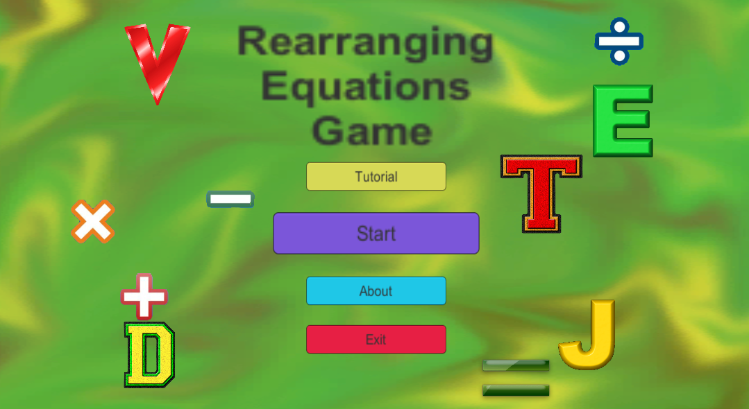
The Tutorial button is where the focus of this project lies. Clicking the button takes you to the next storyboard. The Start button, the About button, and the Exit button were created previously to this project.
Tutorial Screen (not yet created)
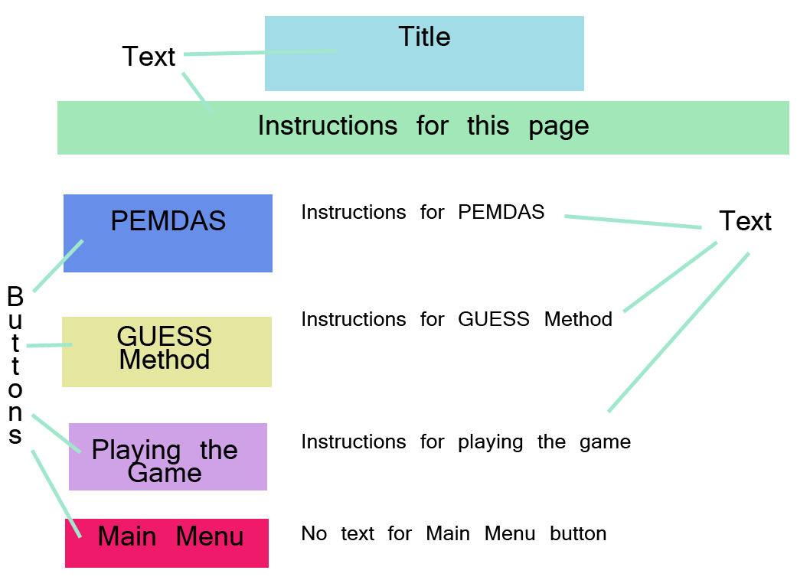
There will be a title at the top with some basic instructions. (both just text with a colored background). There will be four buttons. The PEMDAS button will go to the PEMDAS learning scene, the GUESS Method will go to the GUESS Method learning scene, and the Playing the Game button will go to the tutorial for the equations solving game.
PEMDAS and GUESS Method screen
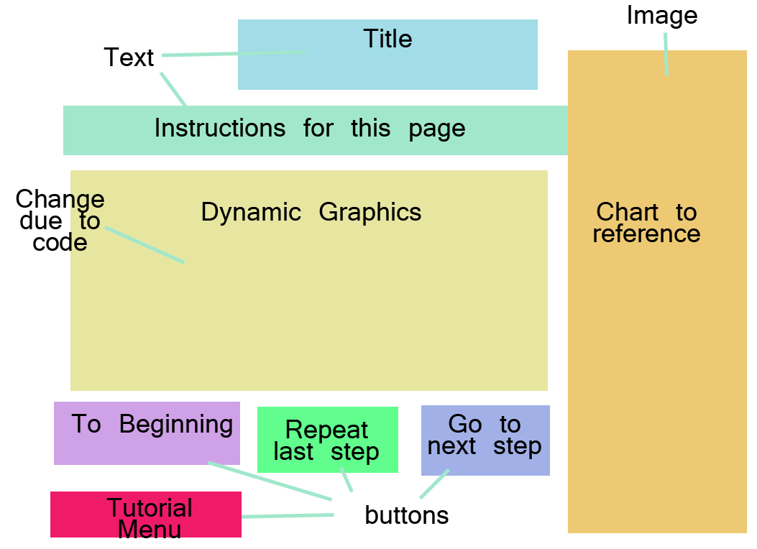
Both the PEMDAS and GUESS Method scenes will be created almost identical, the only difference will be what is displayed in the Dynamic Graphics section as well as the chart that will be referenced. There will be four buttons. To Beginning button will restart the tutorial. Repeat last step button will replay the previous step of learning. Go to next step button will proceed with the next step in the sequence. Tutorial Menu will take the user back to the tutorial menu.
Playing the Game (not yet made)
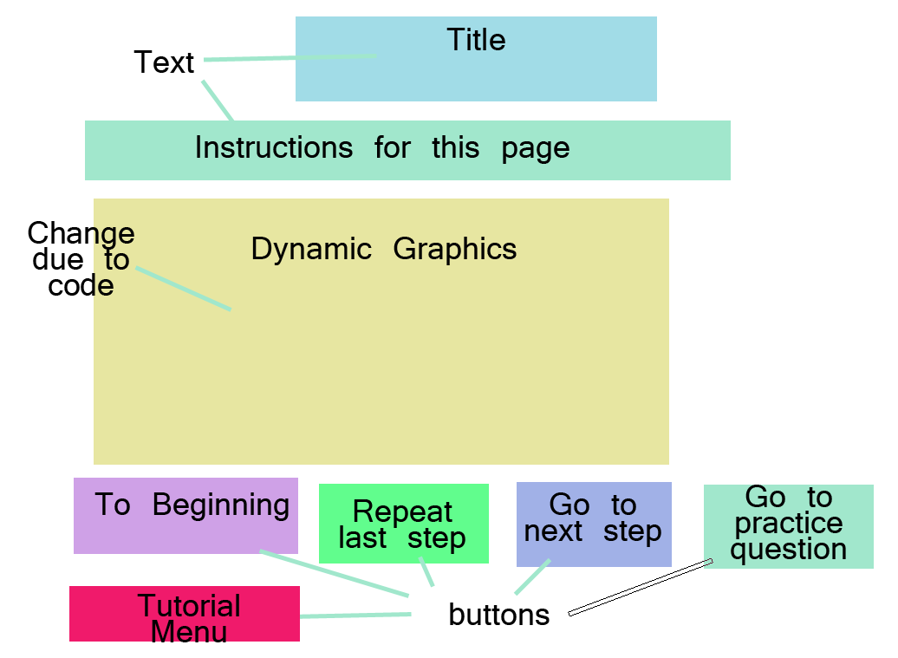
This scene will have a title and instructions in the form of text. There will be an area for dynamic graphics based on what will be learned. There will be five buttons total. To Beginning button will restart the tutorial. Repeat last step button will replay the previous step of learning. Go to next step button will proceed with the next step in the sequence. Go to practice question will proceed to the tutorial for locking items and Tutorial Menu will take the user back to the tutorial menu.

Practice Scene (sort of made)
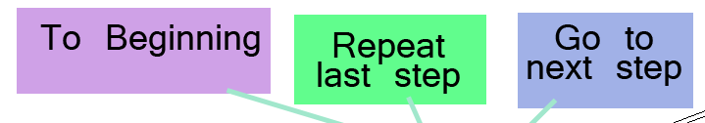
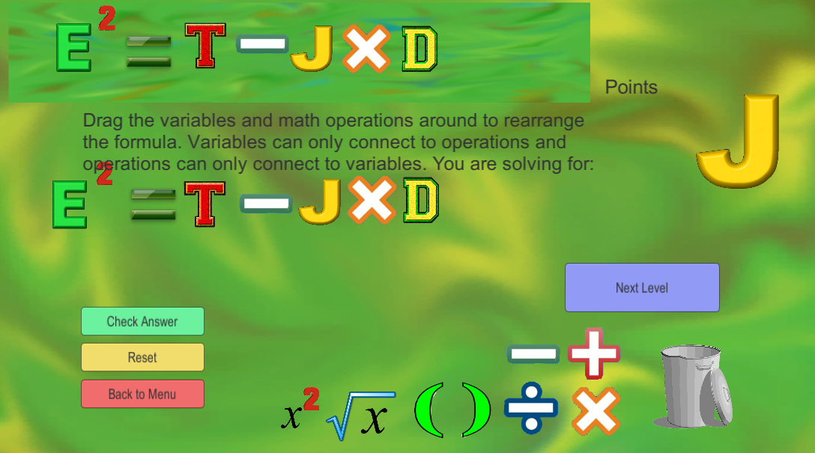
I will use one of the scenes already made and add a few buttons. There will be a simple formula given. The user can go through the steps to link each part in the specific order needed. There will be a systematic process they go through such that they can be successful throughout the game.

