Creating a Game for Manipulating a Formula.
This game is created to help students better learn and use their algebra skills. It is designed for students in a 9th grade Principles of Engineering course. These students come in with a good math skills, but some students struggle throughout the course because of the extensive use of formulas and manipulating the formulas by solving for a specific variable. This game hopes to help with that by giving the students a basic game.
Learning Objective
The learning objective for the game is: Students will learn to rearrange an equation mathematically.
Goals for this Game
We decided as a department that a lot of 9th grade students struggle with the basic math and knowing how to solve for specific variables. A lot of the class is about taking a formula, modifying the formula, plugging in the given numbers, then solving for the specific variable. Students are selected for this class and have demonstrated adequate math and schooling skills. However, some students struggle with the content and the math.
The goal for this activity is to help students become better with their algebra skills by giving them a risk free environment to try to rearrange equations. My hope is that students learn the necessary skills regarding using formulas and equations so they can be successful in every unit within the course.
Outline of Game
The game will open up to a menu and have 4 options: Tutorial, Start, About, Exit. Each will be explained below
- Tutorial: This option will be a screen that will show and tell students how to go through the game. It will give them basic controls and take them step by step to understanding how the game works and how to solve equations.
- Start: This option will be the main option for the students to play. There will be multiple levels for students to attempt. They will be given the formula and be asked to solve for one of the variables. They can click and drag around the variables and math operations. After they rearrange the equation and want to check their answer, there is a button for that. If they are correct, they get experience points and a button appears to proceed to the next level. If they get it wrong they will lose some experience points without knowing. They can always retry and get full experience points.
  - I am not sure how to interlock variables and symbols together. I am thinking of making each variable even and each operation odd. Then only even numbers can interlock with odd numbers and vice versa. If I go this route, I can check my answer by figuring out what is interlocked with the equals sign, then reading each number in the sequence and comparing it with a couple different answers that are uploaded by me.
- About: This option will just have a short paragraph explaining what a students will learn (the objective) as well as what class it is for. It will have an option to go back to the main menu.
- Exit: This option will close the game.

Main Menu Screen
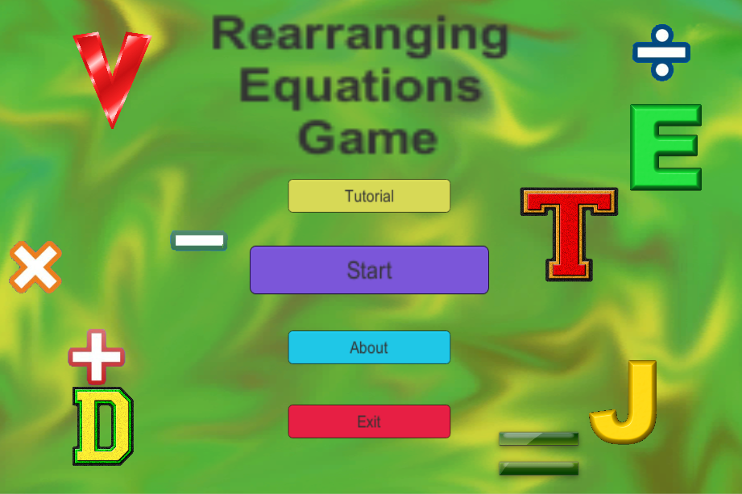
About Screen
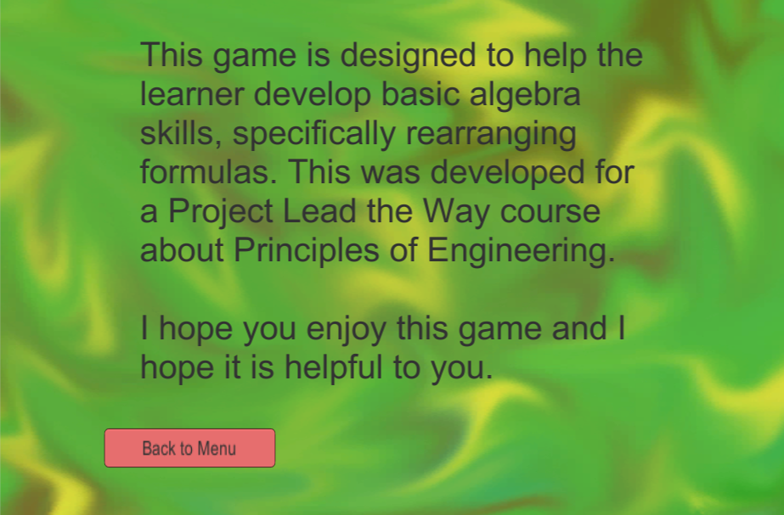

Tutorial Screen – this will be one of the last things I do.
Start Screen – this is still in progress. I have the buttons mostly working and dragging and dropping and cloning operations and throwing away only cloned operations.
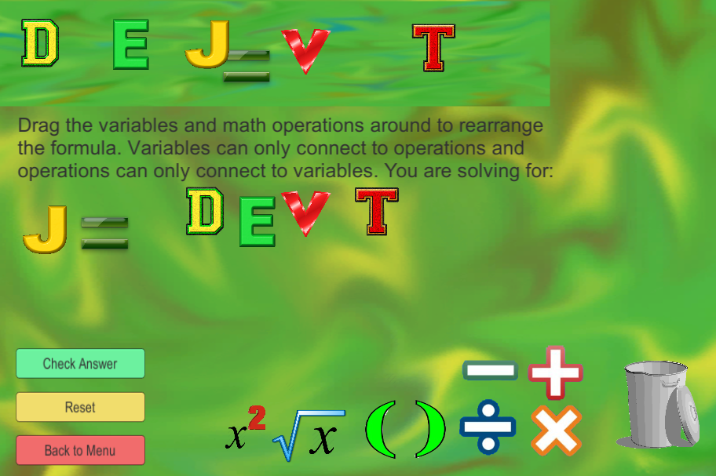
Unfortunately I don’t have the interlocking portion or the checking the interlocking combination. Because that hasn’t gotten any work done on it, I don’t have a good version to beta test. I will try to get a version to be tested once I get those few things working.

