Trevor Brown
ITLS 6390
Curricular Unit Project
Audience
This unit is designed specifically for 9th grade Principles of Engineering class.
Instructional Objectives
Students will:
- Identify sections on the PLTW (Project Lead the Way) formula sheet.
- Rearrange an equation mathematically.
- Identify information in a question.
- Perform calculations using the GUESS Method.
Context
As a department, we have noticed students in 9th grade tend to struggle with performing basic algebra and rearranging formulas in our Project Lead the Way Principles of Engineering classes. The students that are able to take these classes are near the top of their grade in terms of math scores and SAGE testing.
This unit would be one of the first units we have with the students. They come in with knowing basic math skills from 8th grade. They struggle with using the formula sheet and what each variable means. They struggle with reading and understanding a story problem. They struggle with using the GUESS (list the Given, the Unknown, the Equation, Substitute everything in, Solve) method to solving a problem. This unit can also apply to 10th-12th grades learn basic math and engineering skills, but is focused on helping 9th grades with these skills.
Timeline
This unit will last about five class periods with each class period being one and a half hours long.
Units for Parts 1, 2, and 3
Part 1: Objective 1 will be taught in a half of a class period (45 minutes). Objective 2 will be taught in one and a half class periods (135 minutes). The reason for this is Objective 1 is about getting familiar with different formulas and Objective 2 is taking those formulas and being able to rearrange them to solve for a specific variable. The goal isn’t to solve the problem and plug in numbers, but to get to a point that numbers can be plugged in.
Part 2: Objective 3 will be taught in one class period. This objective is a standalone objective. Students need to be able to read through a problem and understand what the meaning is for each given piece of information. The goal is to use their reading ability to know where they need to head next.
Part 3: Objective 4 will take two full class periods. This objective is about knowing how to proceed through a story problem, figure out what is given and what is unknown, pick an equation that solves for the unknown, substitute the given information into the equation, then solve for the answer. This skill is very essential for students to be successful in the class in general.

Part 1
Day 1 Activities:
Objective 1 - Identify sections on the PLTW formula sheet.
- (60 min) Teacher shows the students a PLTW formula sheet and proceeds to provide each student with a copy of the formula sheet. The teacher explains the purpose of the formula sheet, which is to help students realize they don’t need to memorize each formula, but can use this resource to see the different formulas offered to help solve the problem. The teacher will go over each of the section briefly and what unit they will be used. Here is a list of each of the sections:
  - 1.0 Statistics in Probability unit
  - 2.0 Probability in Probability unit
  - 3.0 Plane Geometry in Statics unit
  - 4.0 Solid Geometry in Statics unit
  - 5.0 Constants in many units
  - 6.0 Conversions in many units
  - 7.0 Defined Units in many units
  - 8.0 SI Prefixes in many units
  - 9.0 Equations in many units (Electricity, Thermodynamics, Energy, Statics, based on header of each section
  - 10.0 Section Properties in Statics unit
  - 11.0 Material in Material Testing unit
  - 12.0 Structural Analysis in Statics unit
  - 13.0 Simple Machines in Mechanisms unit
- (35 min) Teacher uses Plickers.com and his/her mobile devise (tablet) to help them get practice navigating through sections, finding formulas, and meanings of variables. Plickers.com is explained more the Transformative Uses of Technology section. The students need plickers cards that they should be given based on the setup of a class. As each question is asked and assessed, the teacher will need to ensure students understand where the information is found and how the information can be used. There are 12 questions total. Some of the multiple choice questions are:
  - What is formula 9.20? A. P = Qp, B. V = IR, C. p = F / A, D. Q = Av
  - How many gal are in 1 L? A. 0.264, B. 33.8, C. 0.621, D. 1.01325
  - In what section is equation 4.7? A. Constants, B. Solid Geometry, C. Plane Geometry, D. Probabilities?
  - What is the heading of the formula 9.14? A. Energy: Potential, B. Energy: Kinetic, C. Energy: Thermal, D. Thermodynamics
  - What does P mean in formula 9.22? A. pressure, B. load, C. power, D. probability
  - What variable is the same between formula 9.13 and 9.15? A. h, B. g, C. U, D. m
- As the students are being assessed through Plickers.com, the teacher can reteach questions that were missed by the students. The teacher can see which students are struggling and make a plan to help students that missed a lot of the questions and spend time with those students during work time.
Day 2 Activities:
Objective 2 - Rearrange an equation mathematically.
- (10 min) The teacher explains that there are many formulas on the formula sheet. However, some of the formulas solve for specific variables. We want to be able to solve for any of the variables. This requires us to rearrange the formulas.
- (45 min) Students log onto the teacher’s EDpuzzle.com course. EDpuzzle.com is explained more in the next section, “Transformative Uses of Technology”. The course will have a few videos assigned to them that they must watch individually during class time. Students use their school email accounts to sign in. While the students are watching the video, they will be quizzed throughout to help build their understanding. The videos are from YouTube.com and have the hyperlinks below. Both videos and embedded quizzes will probably take 30-45 minutes to complete, depending on students needing to replay the videos. The teacher can view the results of the students and help any of the struggling students. These videos can be assigned as homework to struggling students or for students that need extra help.
- (40 min) The students will work through an activity on Canvas that is designed to tie everything together for this portion. Canvas is explained more in the next section, “Transformative Uses of Technology”. The activity will be done in their engineering notebook during class. The activity will have questions about finding certain formulas, what the different variables mean, and rearranging the formulas to solve for a specific variable. None of the problems will have numbers associated with them. The goal for this activity is to make sure they know how to use the formula sheet and know how to rearrange the formulas to be useful to solve for whatever information is given in a problem. Anything the students don’t get done in class, they can take it home and finish it as homework.
Video on physics rearranging formulas - https://www.youtube.com/watch?v=HyH9-5tnS0A
Complex formulas - https://www.youtube.com/watch?v=BCnrcNW9Ay8

Part 2
Day 3 Activities:
Objective 3 – Identify information in a question
- (5 min) The teacher will review briefly on the PLTW formula sheet and answer any questions from the previous day. The teacher will proceed with the daily lesson and tell the students about the objective (above) for the day.
- (10 min) The teacher will show a video on YouTube.com called “5 Riddles Popular on Logic | To Test Your Brain” (https://youtu.be/HCp_eN6JSac). An explanation on using YouTube.com is in more detail in the next section, “Transformative Uses of Technology”. This video is about 7 minutes long, but it helps students start thinking and help students see that story problems aren’t difficult, but require time, analyzing and processing information. This video is designed to get students motivated to do story problems.
- (15 min) The teacher will have multiple story problems (ten or so) on a SMART board using the SMART Notebook application. The teacher will work through an example on the board of identifying the important parts given from the story problem. The teacher goes sentence by sentence explaining what the meaning of each word and how it applies to the problem (if it does). The teacher lists out each of the values below. Students take notes while the teacher is discussing the strategies. The teacher works through another example, but getting more help from the students. The teacher should be analyzing the students on who is getting it and who isn’t. The teacher will help struggling students during the next activity as needed.
- (25 min) Once the students have a basic idea of working through a story problem and solely identifying the parts to the problem, the teacher goes to the remaining story problems that are on the SMART board and has students come up to the board and identify different parts to the problems. Students take turns by tables to figure out what information is needed to proceed with the problem. As the students are doing this, they can receive help from other students or the teacher. The teacher has a few moments to help struggling students as needed while students are doing this activity.
- (30 - 40 min) After the students have worked through the SMART board examples, the students will work either alone or in small groups on identifying important information from story problems. The assignment will be on Canvas and will be done in their engineering notebook. More information on Canvas and its use is found in the next section, “Transformative Uses of Technology”. Students will spend the rest of the class period working on this activity. While they work, the teacher can help any struggling students and answer any questions about the activity. If students don’t finish in class, they can do the rest of the assignment at home.
- (last 10 min) The teacher lets students know to start cleaning up and that the assignment will be graded in the next few days. The teacher emphasizes the importance of this skill throughout the class and explains the objective again. The teacher shows half of another YouTube.com video to keep students excited “Can you solve the fish riddle? – Steve Wyborney” (https://www.youtube.com/watch?v=lLOALyWls2k) and to have students try to figure this out before the next class period.

Part 3
Day 4 Activities:
Objectives 4 - Perform calculations using the GUESS Method.
- (10 min) The teacher will review briefly on the PLTW formula sheet and answer any questions from the previous day about reading a story problem. The teacher will do two problems reading and identifying parts to a story problem. Once the short review and the questions are done, the teacher will proceed with the daily lesson and tell the students about the objective (above) for the day.
- (10 min) The teacher will show a video on YouTube.com called “Funny Puppy Problem Solving” (https://youtu.be/1RewOA9OiGY) first and discuss the need to problem solve. Then show the YouTube.com video called “Can you solve the bridge riddle? – Alex Gendler” (https://youtu.be/7yDmGnA8Hw0) next. An explanation on using YouTube.com is in more detail in the next section, “Transformative Uses of Technology”. These videos combined are about 5 minutes long, but it helps students start thinking and help students see that story problems aren’t difficult, but require time, analyzing and processing information. These videos are designed to get students motivated to do story problems.
- (60 min) Students will be directed to Canvas to work on the assignment for doing calculations using the GUESS Method. The assignment has 20 story problems. The assignment will have a Google Doc version of the assignment if students want to work on it through Google Docs by making a copy of it. An explanation on using Canvas and Google Docs is in more detail in the next section, “Transformative Uses of Technology”. Students could also work on it solely in their engineering notebook. Students ultimately will have their work in their notebook. Each problem must have each step shown. During this time the teacher can help students as needed. Assign whatever they didn’t get done as homework to be completed by the next day.
- (last 10 min) The teacher lets students know to start cleaning up and that the assignment will be graded in the next few days. The teacher emphasizes the importance of this skill throughout the class and explains the objective again. The teacher shows half of another YouTube.com video to keep students excited. The video is called “Can you solve the virus riddle? – Lisa Winer” (https://youtu.be/ZKh6z0X6KRw) and ask students to try to figure this out before the next class period.
Day 5 Activities:
Objectives 4 - Perform calculations using the GUESS Method.
- (10 min) The teacher will review briefly on the PLTW formula sheet and answer any questions from the previous day about reading a story problem. The teacher will do two problems reading and identifying parts to a story problem. Once the short review and the questions are done, the teacher will proceed with the daily lesson and tell the students about the objective (above) for the day.
- (20 min) Students will continue to work on the assignment on Canvas for doing calculations using the GUESS Method. The assignment has 20 story problems. The assignment will have a Google Doc version of the assignment if students want to work on it through Google Docs by making a copy of it. Students could also work on it solely in their engineering notebook. Students ultimately will have their work in their notebook. Each problem must have each step shown.
- (45 min) The teacher will grade a select number of problems from the assignment as a class. There will be eight problems at the choosing of the teacher to grade. The teacher will use the SMART board with the problem statement on the board. The SMART board application will be used for displaying the problem statements such that you can also write on the board. The SMART board and the SMART board application are explained more in the next section, “Transformative Uses of Technology”. The teacher will call on students to come up to the board, provide information to the questions and answer the questions. Students will get multiple times to come up. Students can correct their work as needed. If any questions arise, they can be answered on the spot.
- (last 15 min) The teacher will wrap up the unit and re-emphasize the importance of these skills during this course. The teacher will discuss with the students strategies they used to solve these types of questions. The class will discuss struggles that they had and how to overcome those struggles in the future. The teacher will show students additional problems found on Canvas in case a student wants additional help.

Transformative Uses of Technology
Each Objective’s Technology
For Objective 1 the technology that is used is Plickers.com.
For Objective 2 the technologies that are used are EDpuzzle.com and Canvas
For Objective 3 the technologies that are used are YouTube.com, a SMART board and the SMART Notebook application, and Canvas.
For Objective 4 the technologies that are used are YouTube.com, a SMART board and the SMART Notebook application, Google Docs and Canvas.

Descriptions of Each Technology
Plickers.com is used as an informal assessment tool for the teacher to gauge how well students are able to use the formula sheet. It gives the teacher results of which students are struggling so he/she can target those struggling students and give them more attention.
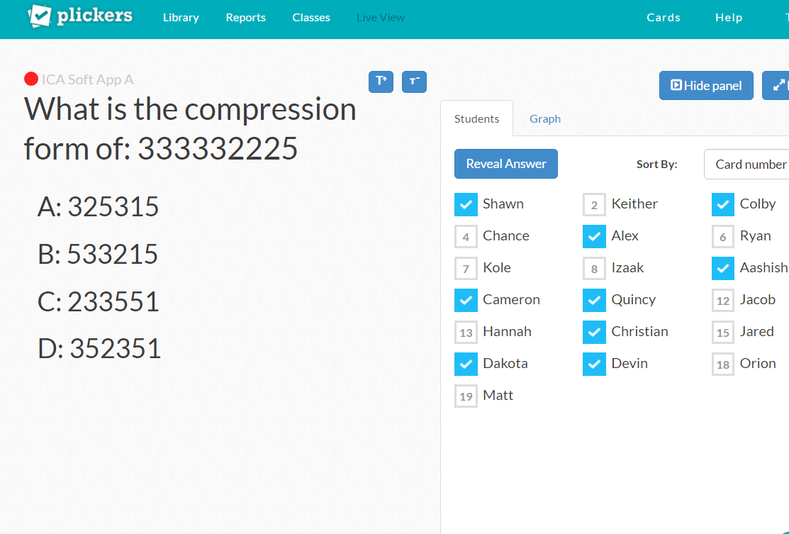

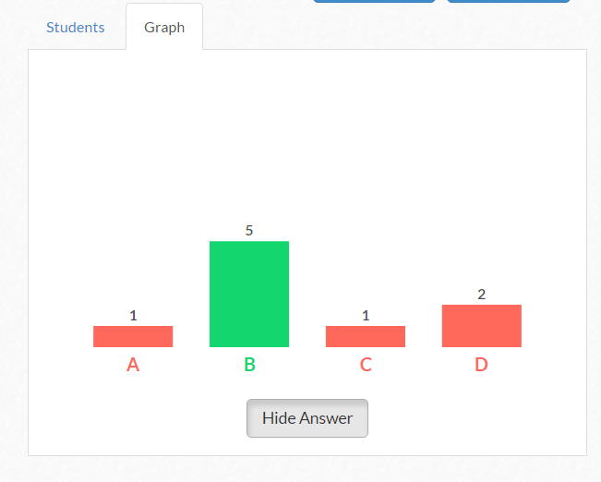
The reason we are using Plickers.com is to help the teacher quickly identify the students that understand and pick out which students need extra help. Every student can answer the question in a matter of 30 seconds. Because Plickers.com is digital, responses come quick and a teacher can immediately know what they should do, whether it is reteach, go on, pick out students for help, create groups based on the results, etc.
EDpuzzle.com is used as a video learning tool that utilizes embedded quizzes during the video. Students not only watch the video, but must pay attention to the video in order to answer the questions correctly. The teacher can see the results of the students. This tool gives the teacher an idea of which students aren’t understanding the video and the teacher can focus on helping those students more.
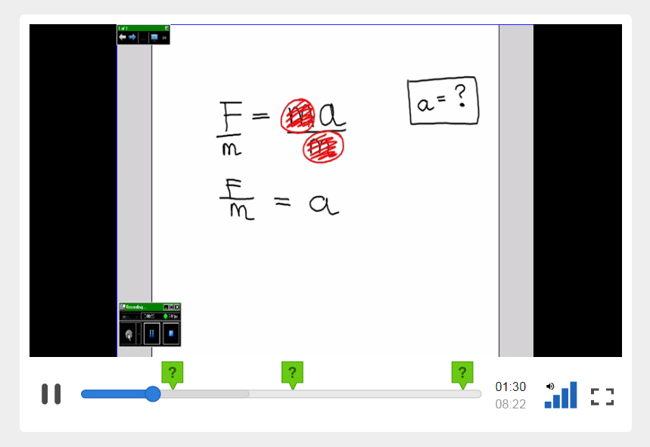
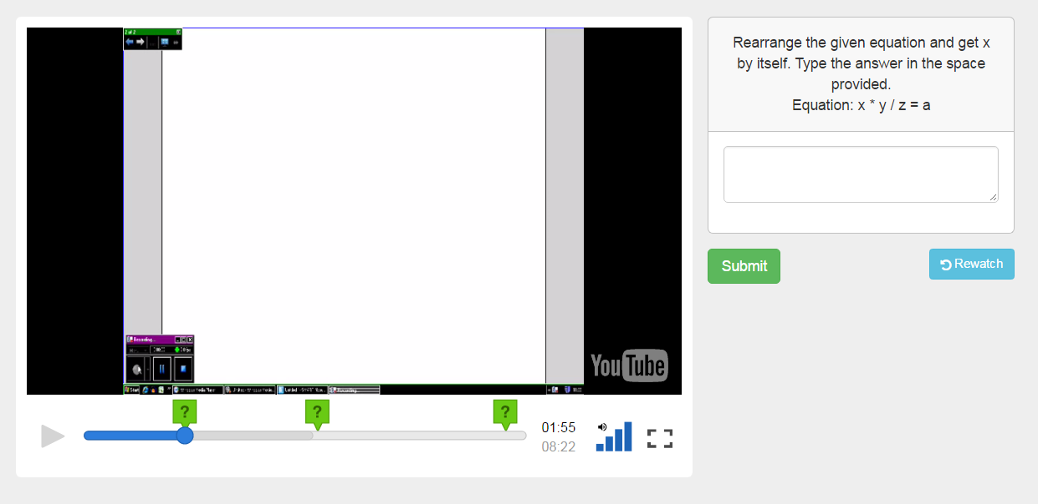
The reason we are using EdPuzzle.com is because it gives the students a chance to learn the material away from the teacher and do practice problems. This frees up the teacher to work more closely with students that are stuck with the first objective. The teacher can still assign this as homework to students that don’t finish in class or were absent or were getting help with other material. This gives the teacher some good flexibility on what could help their classroom flow better.
YouTube.com is a tool that lets you show a lot of different videos to your class. This helps present what other people have done and help your students get someone else’s perspective on the matter. There are a lot of good educational videos that teach. There are a lot of videos that get students motivated to learning the material.
The reason we are using YouTube.com in this lesson is because it changes up the classroom from being a teacher-centered classroom and lets a video teach instead of the teacher. When the teacher teaches each day, students become less interested in the material just because it is routine that the teacher teaches. Adding a video occasionally lets students see a different side and break out of the routine. Videos can help students get more interested and motivated to watching and learning. Short videos help a lot with this, similar to the videos that are planned on being showed. In the book Rethinking Education in the Age of Technology, Collins and Halverson described how students are bored in schools and are losing interesting in learning. Incorporating this will help students realize the usefulness of YouTube.com for learning.
Images of the videos are shown below.
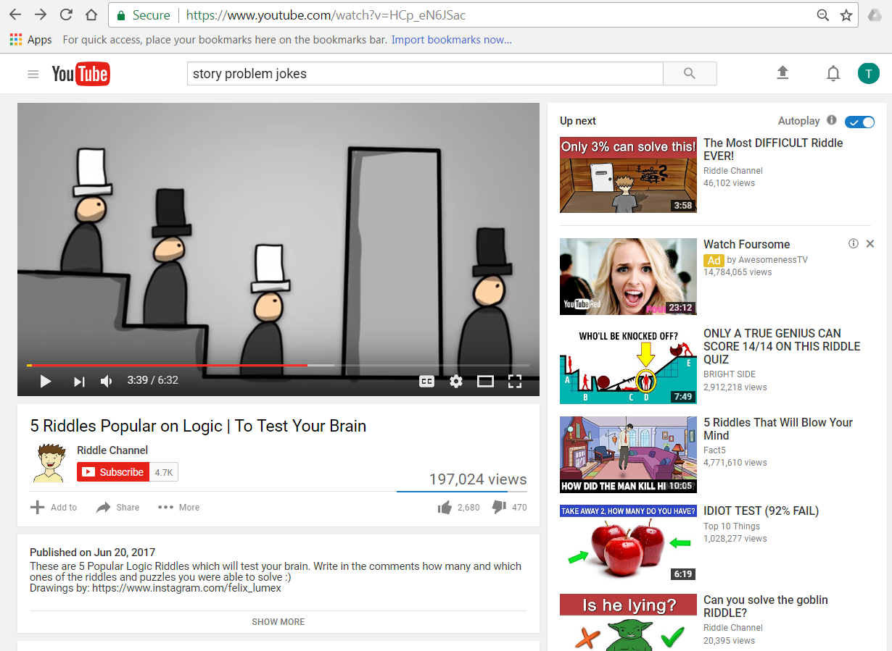
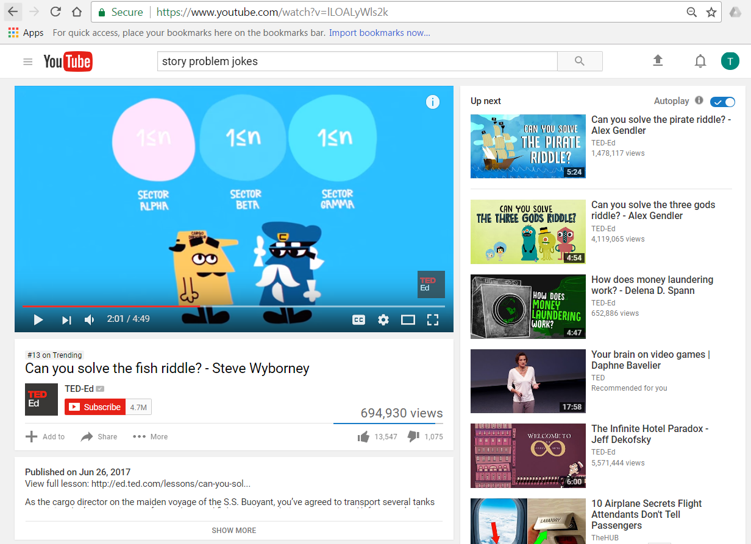
A SMART board is a tool for displaying information near the front of a classroom (or wherever you decide to put the board to be most effective). The SMART board can display videos, notes, images, demonstrations, applications, etc.
The SMART Notebook application is a tool for writing on the SMART board. This application is used mostly for notes. You can work through examples real time by using technology as a touch screen. You can easily change colors, add images, etc.
The reason we use the SMART board and the SMART Notebook application is to incorporate the computer into displaying certain information. The SMART board lets us show multiple different educational images or visuals. The SMART board lets anyone interact with it. You are able to pull up videos on the fly, change between a PowerPoint to a web browser. You can search for an image or website. You can use your computer and display whatever is on your computer for the students to see. This uses technology to aid in dispersing information to all of you students.
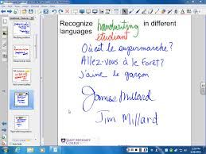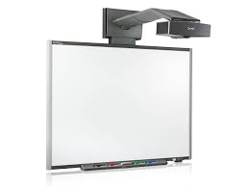

Google Docs is an online tool that lets the teacher create documents that can be viewed through Canvas (Canvas explained more below) and can be shared with students to create their own copies. Students can copy the document and the copied version in their Google Docs and edit their document as needed.
The reason we are using Google Docs is because many students have a Google Account, which comes with many of these tools. Students can start learning how to utilize these online tools and how to share and collaborate with each other. Students get to learn the tools many professionals use. The point of going through school is to learn how to be productive in society. These skills they learn from Google Docs helps them learn many of the 21st century skills for being creative, communicative, and collaborative. The students get a first-hand experience on how to be a productive member of society.
Canvas is an LMS that lays out all of the content for the course. Students have access to Canvas wherever they go, so long as they have an internet connection. Students can use any of the resources found on Canvas no matter where they go. This tool helps teachers be more organized with their online content.
The reason we are using Canvas is because students can access the information wherever they go and the information can’t be lost. It also lets the teacher communicate specific goals, learning, and activities to the students for the class. This tool helps transform the learning such that it can happen anywhere and not just in the classroom. In the book Rethinking Education in the Age of Technology, Collins and Halverson mentioned the need to teach students to be lifelong learners. Canvas helps students take control of their learning through an online median. Becoming a lifelong learner almost requires access to the internet such that anyone can learn anywhere. Canvas helps students realize this and gives them a chance to be connected to online educational content.

